BAS Club login and password help and instructions
To sign in and access the members’ area you need a Username, or your Email Address and Password
- First go to the BAS Club website www.basclub.org
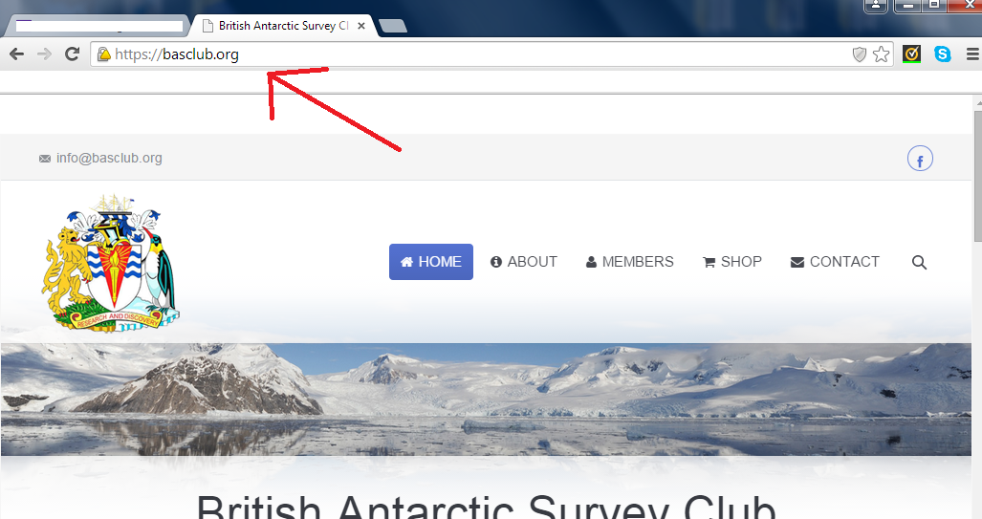
- Next click on the ‘Members only’ section
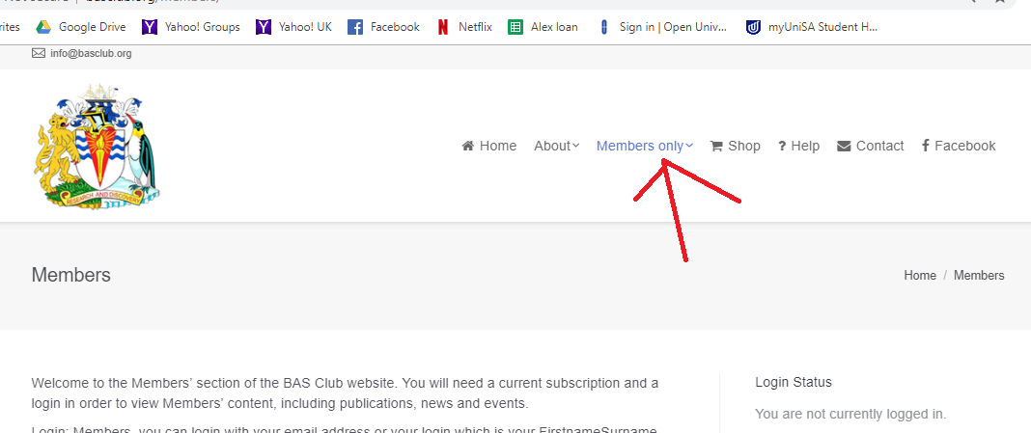

- Then Login
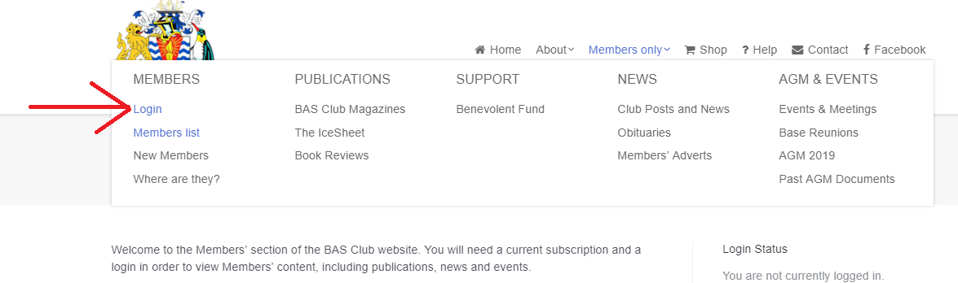Scroll down and you can see the login boxes on the right
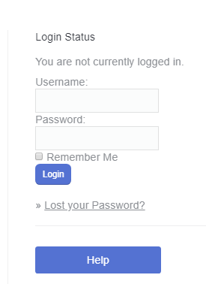

- Your Username is your name and surname as one word eg JohnSmith (as capitalized, without spaces). Or you can type in your Email Address.
- Once a month (or so) the website will check you are a person and not a ‘robot’ or computer trying to hack the site. It will ask you to look at a photograph of words or numbers and type them in. We must have this security facility because our website holds names and email addresses of our members. Sometimes once this happens it takes you to a login screen and you appear to get ‘stuck’ – if this happens go back to step 1 and this time it won’t check you are a robot and you should get in easily.

- But if you aren’t sure of your username, or if you are doing this for the first time, or if you have lost your password, then click on ‘lost your password’

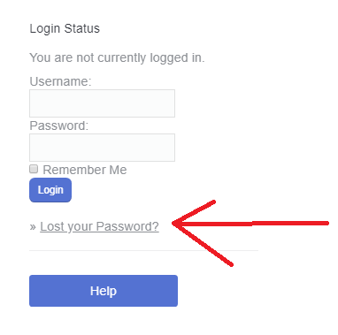
Enter your email address and click on ‘Get New Password’
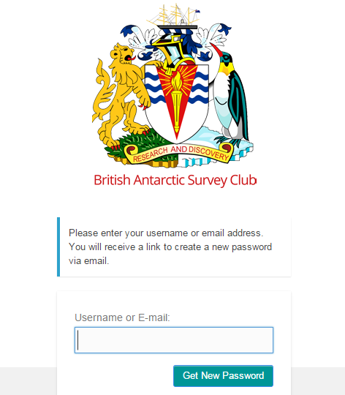
- You will get an email like this which has your Username in it as well

Subject: RE: Your membership login info
Dear XXXXX,
Our records show that you recently asked to reset the password for your account.
Your current information is:
Username: XXXXXXX
Membership: BAS Club Members
As a security measure all passwords are encrypted in our database and cannot be retrieved. However, you can easily reset it.
To reset your password visit the following URL, otherwise just ignore this email and your membership info will remain the same.
http://basclub.org/member-login?action=rp&key=irQAvx4oJX&login=
Thanks,
Membership Secretary

- Click on the link and you will get a screen allowing you to put in a new password
- Type in the new password twice
- Return to the login screen eg through the members section. Note you may have to start from (1) again with the BAS club website if you find yourself in a loop where it keeps asking you to reset your password.
- To login type in your Username and your new password
Please note – if you have recently changed your email address make sure to tell the Club Membership Secretary. For security reasons, members cannot change their own email addresses.
For technical support please email info@basclub.org

